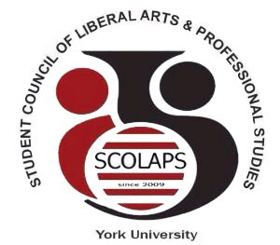

Student Council of Liberal Arts and Professional Studies
York University
South Ross Building, Room 124 | T: (416)-736-2100 ext. 55977
E: scolaps@gmail.com | Web: www. http://student-council.laps.yorku.ca/

______________________________________________________________________________

SCOLAPS Executive and Director Team Meeting
Thursday February 8th 2018, 6-8pm
North Ross 940 (Senate Chambers)

- Call to order and approval of the agenda
- Chair’s remarks
- Updates from the Faculty
  - Senate
  - Faculty Council
  - Academic Policy and Planning Committee
  - Committee on Curriculum, Curricular Policy and Standards
  - Tenure and Promotions Committee
  - Committee on Research Policy and Planning
  - Committee on Teaching and Learning and Student Success
- Upcoming events
- SCOLAPS Elections: Senator speeches
- Presentation: Let’s Talk Mental Health
- Other business
- Motion to adjourn

