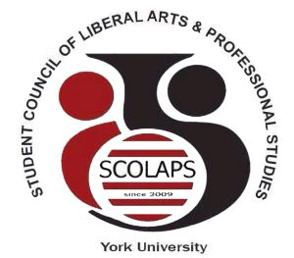

Student Council of Liberal Arts and Professional Studies
York University
South Ross Building, Room 124 | T: (416)-736-2100 ext. 55977
E: scolaps@gmail.com | Web: www. http://student-council.laps.yorku.ca/

______________________________________________________________________________

SCOLAPS 5th General Council Meeting
Thursday, January 11th 2017, 6-8pm
Senate Chambers (North Ross 940)

- Call to order
- Approval of the Agenda and Minutes from November 9th 2017
- Chair’s remarks
- Updates from the Faculty
  - Faculty Council
  - Senate
- Committee updates
  - Academic Policy and Planning Committee
  - Committee on Curriculum, Curricular Policy and Standards
  - Tenure and Promotions Committee
  - Committee on Research Policy and Planning
  - Committee on Teaching and Learning and Student Success
- Upcoming events
- Treasurer’s report
- LA&PS International Student Engagement Coordinator report
- Join the Conversation: International Student Issues
  - Q&A session with York International
  - Global Learning
- Alumni Presentation by Dalubuhle Ndlovu
- Other business
- Motion to adjourn

