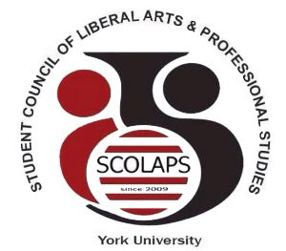

Student Council of Liberal Arts and Professional Studies
York University
South Ross Building, Room 124 | T: (416)-736-2100 ext. 55977
E: scolaps@gmail.com | Web: www. http://student-council.laps.yorku.ca/

______________________________________________________________________________

SCOLAPS Special Meeting
Thursday, January 25th, 2018 from 6-7pm
North Ross 940 (Senate Chambers)

- Call to order and approval of the agenda
- Chair’s remarks
- Discussion: Vacant senator positions
- Item for action: Senator criteria
- Election timeline and CRO
- Other business

