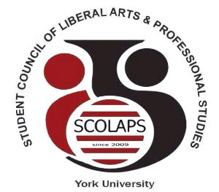

Student Council of Liberal Arts and Professional Studies
York University
South Ross Building, Room 124 | T: (416)-736-2100 ext. 55977
E: scolaps@gmail.com | Web: www. http://student-council.laps.yorku.ca/

______________________________________________________________________________

SCOLAPS 2018/19 Executive Elections
Thursday April 12th 2018, 6-8pm
Room 313, Student Centre

- Call to order and approval of the agenda
- Chair’s remarks
- CRO introduction
- Executive election speeches
- Other business
- Motion to adjourn

